SHARWIL BHENDE
23070521137

CN: PRACTIAL NO.1

AIM: STUDY OF BASIC ELEMENTS OF COMPUTERS NETWORKING WITH DETAILS OF NETWORKING DEVICES.

• Hub: A simple networking device that broadcasts data to all connected devices without filtering.
• Switch: A device that forwards data only to the intended device using MAC addresses.
• Router: Connects multiple networks and directs data packets based on IP addresses.
• Repeater: Amplifies and retransmits network signals to extend coverage.
• Bridge: Connects and filters traffic between two different LAN segments.
• Modem: Converts digital data into analog signals (and vice versa) for internet access.

Topology: The arrangement or layout of devices and connections in a computer network.

• Bus Topology: All devices share a single central communication line (backbone).
• Star Topology: All devices connect to a central hub or switch.
• Ring Topology: Devices are connected in a circular path where data passes in one direction.
• Mesh Topology: Every device is connected to every other device for maximum reliability.
TYPES OF CABLES
• Twisted Pair Cable: Consists of pairs of insulated copper wires twisted together, commonly used in LANs.
• Coaxial Cable: Has a central conductor, insulating layer, and shield, used for cable TV and networking.
• Fibre Optic Cable: Uses light signals through glass/plastic fibers for high-speed, long-distance communication.

NETWORK TROUBLESHOOTING COMMANDS:

1.PING

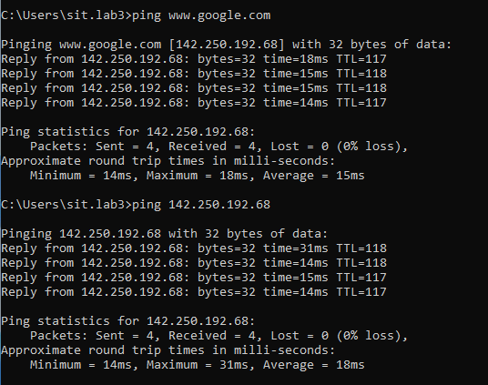

2.IPCONFIG

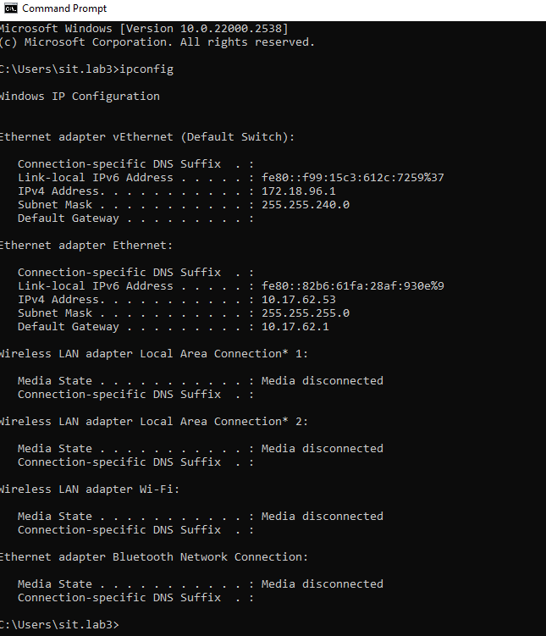

3.TRACERT
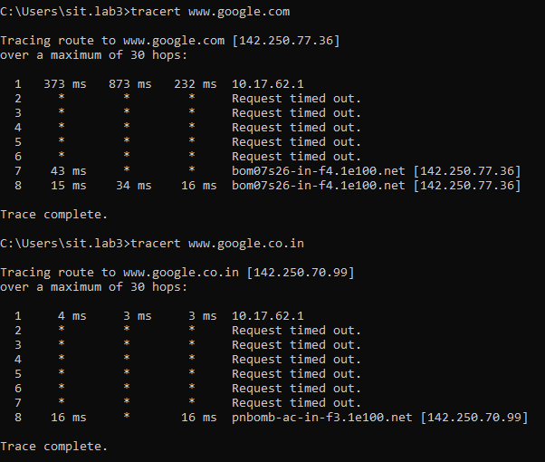

4.nslookup
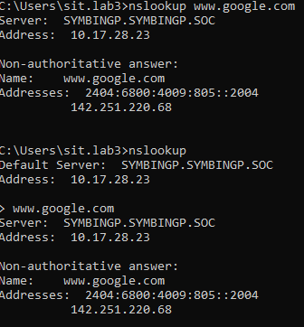
5.ROUTE PRINT

